Aspire
Management Consultancy

SESSION 3 – UNDERSTANDING SELF AND OTHERS – HANDOUT
Questions:

- On a scale of 1 to 10, how well do you know and understand the individual needs and aspirations of your team members?
- Why did you score that way?
- Do your team members agree?

DiSC (Dominant-Influential-Steadfast-Conscientious)

Plot your position on these axes:

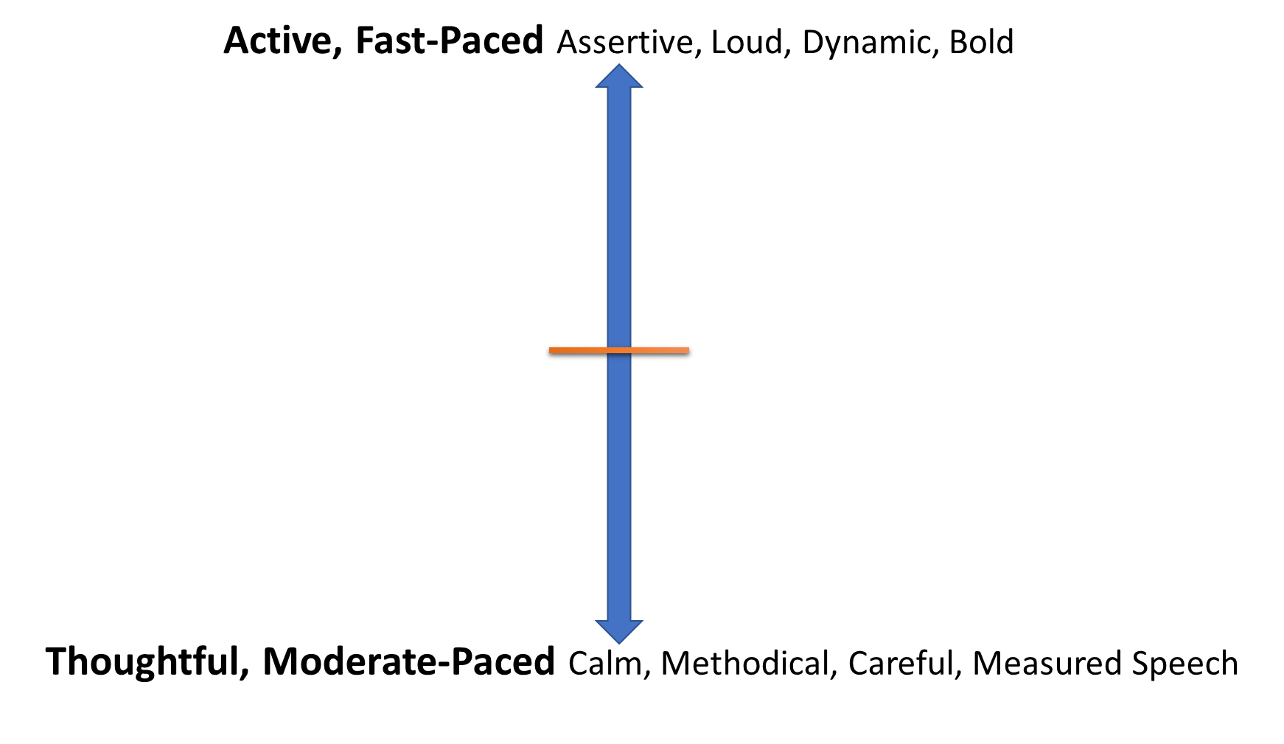

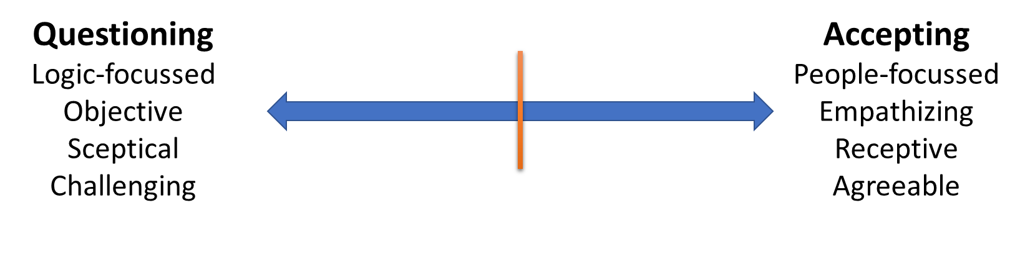
Question: Where are you and your team?

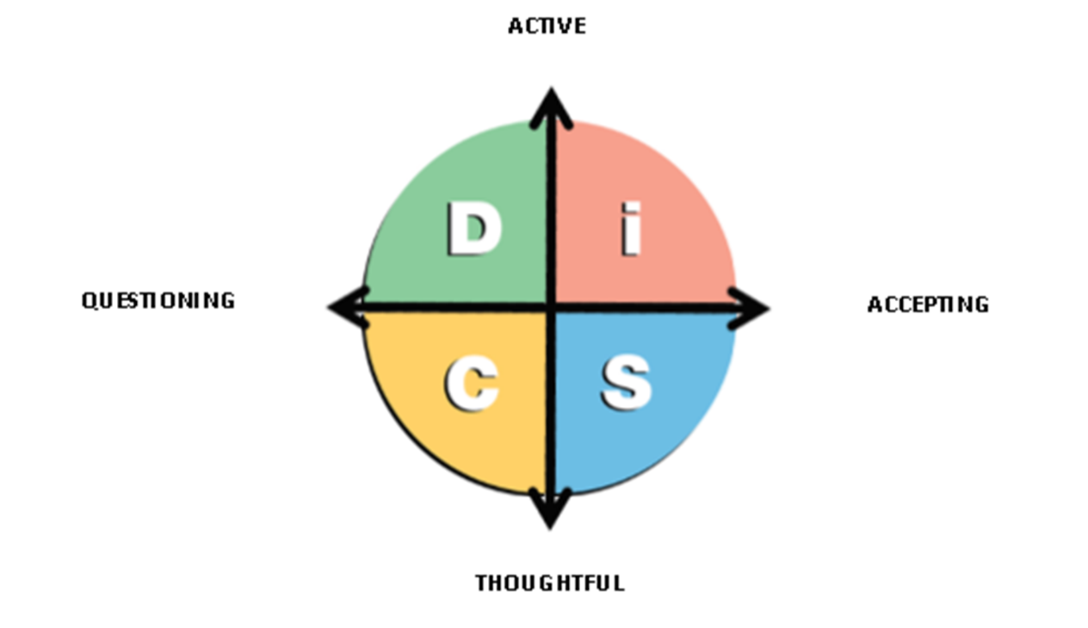

Questions (for groups):

- What is your preferred way of doing things?
- What are the strengths of your particular style (what are you good at)?
- How should people approach you to get the best response?

DiSC – Typical Group Traits

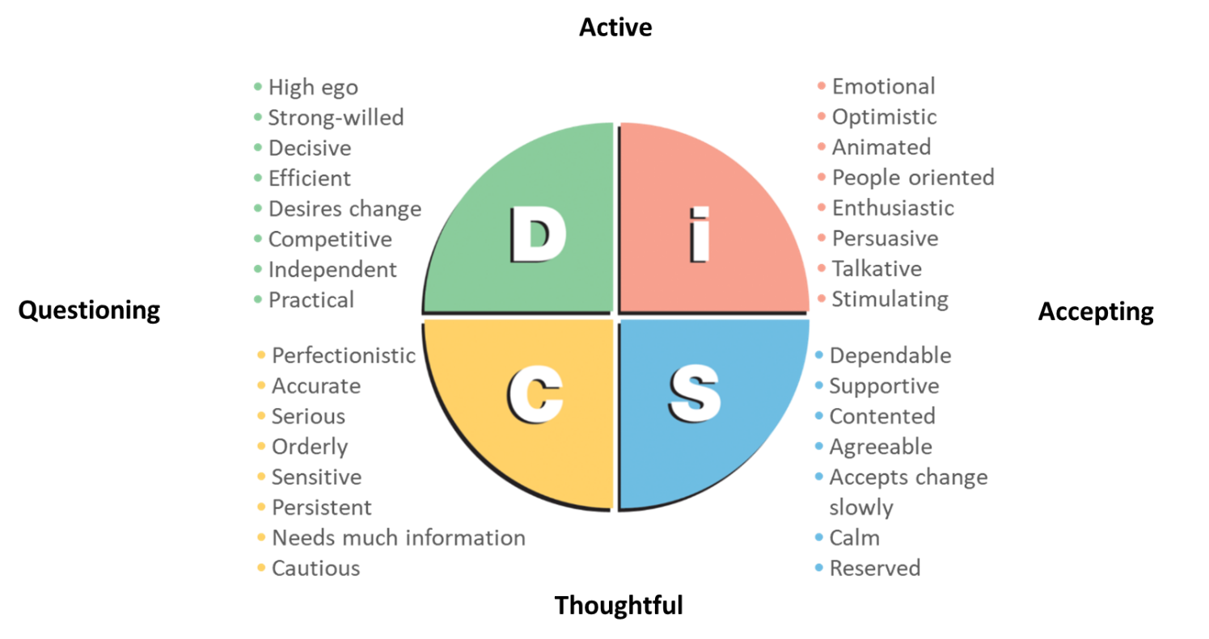

Questions:

- When can your strengths be particularly helpful?
- What are you having to do at the moment that does not play to your strengths?
- What happens when you have to use a different strength for protracted periods?

Questions:

- What does it look like to you when those strengths are overdone?
- What does it look like to others when your strengths are overdone?
- What does it look like when other groups overdo their strengths?

Overdone Strengths

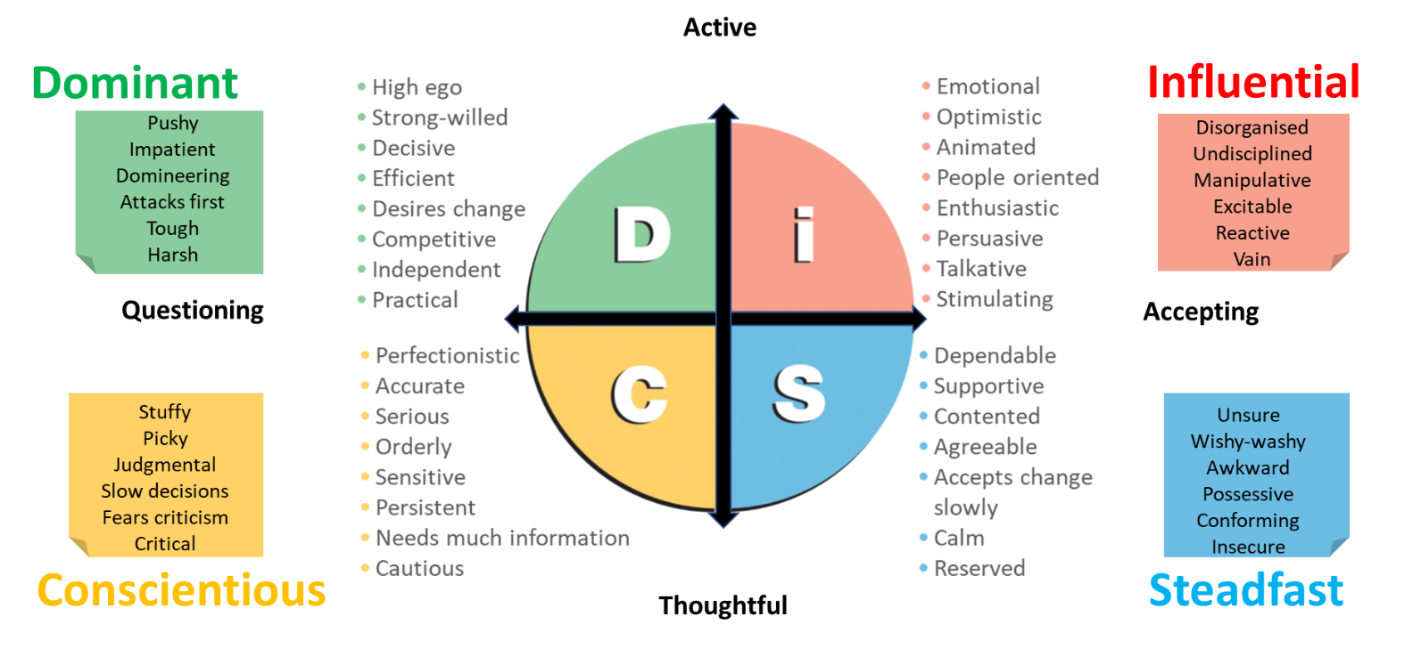

Questions:

- How does your group want to be approached when in conflict or under stress, and what should not be done?
- How does your group think the other groups want to be approached?
- What are the implications of your team members’ positions on the DiSC map?
- What are the key takeaways for you and your team?
- What, specifically, are you going to do differently (as individuals and as a team)?
- How well do you as a leader understand the needs and preferred behaviours of your team as individuals (rescore earlier exercise)?

Questions Score from 1 to 10):

Skills
- How aware are you of the skills required for your present role?
- To what extent do you think you have them?
- How aware are you of the skills that will be required in the next 5 or so years?
- To what extent do you have those?

Attitude
- How motivated are you in your current role?
- How much do you enjoy it?
- How good are you at doing things even when you do not feel like doing them?
- How good are you at dealing with and learning from setbacks?
- How willing are you to voluntarily share information that will help others?

Preferences
- How clearly do you understand your preferred working patterns?
- How well do you understand your normal leadership and team working style?
- How good are you at flexing your style, or adopting a different style, to meet the needs of the situation?

Habits
- To what extent do you have a sound routine for your daily work?
- To what extent do you know the conditions you need to work best?
- How good are you at putting those conditions in place?
- How good are you at scheduling your more demanding tasks for times when you perform at your best?
- How good are you at managing distractions?
- How effective are you at learning from experience?

Planning
- How good are you at reflecting on and amending your approach to work and personal development?
- How effective are you at finding and using tips, course, guidance, etc. to improve your performance?
- How quickly do you recognize when your personal development strategy is not being effective and adapt it as required?

Values
- How good a fit are your values for the team and organization?

Notes:

Contact us for details of online DiSC and other assessments:

Email: enquiries@aspiremcl.co.uk
Phones:
020 3903 9288
020 3904 7501
01522 700465

